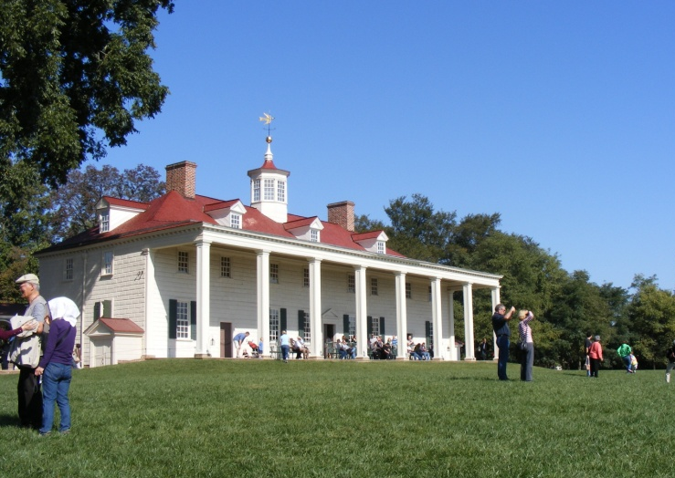
Mr. Roadcap
6th Grade Social Studies
Elkton Middle School, Room 202
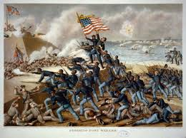
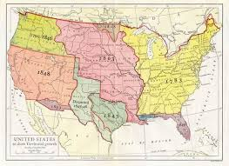
lroadcap@rockingham.k12.va.us

U.S. History Course Description | Throughout this semester-long class we will discover the proper way to read maps, learn major geographic features of the United States, and explore the history of the United States from the colonial time period to the end of the Civil War.
Classroom Guidelines | - Respect all others.  - Be honest.  - Come prepared to class.  - Be ready to learn when class begins.  - Have fun while learning!
Digital Conversion | Students will interact with various pieces of technology in my classroom, including many instructional websites. These devices are property of Rockingham County Public Schools and students are expected to abide by rules in the RCPS Acceptable Use Policy, outlined in the student handbook. Students who are found to not be using the device correctly will face consequences, which could include losing the privilege of using technology.
Cell Phone Policy | Cell phones and other personal electronic devices will only be used in class with direct instruction from the teacher.
Grading | Homework:  Classwork:  Quizzes/ Projects:  Tests: | 10%  20%  30%  40%
Grading Scale | A = 100-90  B = 89-80  C = 79-70  D = 69-60  F = 59-0  PowerSchool grades will be current and entered on a weekly basis when there are graded assignments.
Missing Assignments | It is very important for students to take responsibility for getting and turning in assignments when due. Assignments that are turned in one class meeting late will have a 10% deduction. Assignments turned in two class periods late will have a 20% deduction. Assignments turned in beyond two class periods late will receive a 50% deduction from that assignment’s final grade.  Students will be given one day for every excused day absence to complete missed assignments.  Three missing homework assignments equals a minor.
Homework | Students should expect to have some homework nearly every evening. If homework is not given, students will be expected to go over their notes for homework. Homework may be graded.  Every EMS student has a school planner. This planner will be used daily in class and time will be given at the end of class for each student to write in assignments, late work, upcoming events, and may be used for communication. Please check your child’s planner daily. Additionally, students and parents will be able to find homework assignments and upcoming assessment notifications on Homework Hotline, Remind 101, and my website: www.roadcaphistory.weebly.com.  Students who have Internet access at home should check Google Classroom in the event of a snow day or absence for any important announcement.  Students who may be struggling with a class will receive remediation during Prime Time. This is a 47-minute class that is graded and includes reading, remediation, and relationship (the 3 Rs).
Classwork | Classwork will be turned in for a grade. Classwork may include a binder check periodically to ensure students have the proper organization and necessary materials to be successful.
Projects | Throughout the year, students will complete projects – usually one or two every grading period. Normally, projects are done during class time and involve working alongside classmates. Although there may be occasions when students will need to work on a project at home.
Quizzes | Students will have various quizzes throughout each unit. Quizzes will be graded.
Tests | Students will have a test at the end of every unit. These tests may include matching, multiple choice and short answer questions.

Sign and Return

Student: ______________________________________________

Parent(s)/ Guardian(s): _____________________________________

What is the best way to contact you?
Phone: __________________________  Other: ___________________________ | Email: __________________________  Best time to contact: _______________

Please check the appropriate box related to your child’s Internet access at home. This information will be important as we continue to move forward with digital conversion.

My child has daily access to the Internet.

My child has occasional access to the Internet.

My child does not have access to the Internet at home.

Please use the back of this paper to list any concerns you may have at this time. My email address and school phone number is printed below in case you need to contact me during the school year.

Email: lroadcap@rockingham.k12.va.us
Phone: (540) 298-1228

Please sign below stating that you have read and understand the 6th grade social studies syllabus.

________________________________________ _____________
(Student Signature) (Date)

________________________________________ ____________
(Parent/ Guardian Signature) (Date)

