Part I: Matching: Please match each description with the correct branch.

_____1. This government branch has the ability to veto laws. | E = Executive
_____ 2. This government branch makes laws. | L = Legislative
_____ 3. This government branch determines whether laws are constitutional. | J = Judicial
_____ 4. This government branch checks the power of the executive to appoint
judges to the Supreme Court.
_____ 5. This government branch has the power to tax.

Part II: Chronological Order: Please number the presidents in the correct chronological order.

_____ Thomas Jefferson | _____ George Washington | _____ James Monroe
_____ James Madison | _____ John Adams

Part III: Multiple Choice: Please select the best answer for each question.

_____ 1. The U.S. Constitution established what type of government?
A. State-centered government based on individual liberties
B. Federal system of government based on shared power between the national government
and states.
C. Developed a loose connection between the states with a weak national government
D. A government modeled after British Parliament with few freedoms

_____ 2. Prior to developing a Constitution, what type of government did the United States have?
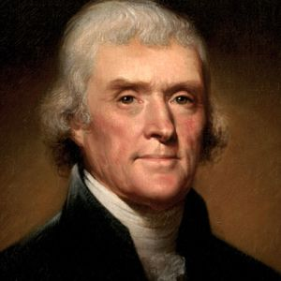
A. Articles of Confederation C. Declaration of Independence
B. Magna Carta D. Bill of Rights

_____ 3. Which Founding Father wrote the Virginia Statute for Religious Freedom?
A. George Washington C. Thomas Jefferson
B. John Adams D. James Madison

_____ 4. Which constitutional amendment was based on the Virginia Statute for Religious Freedom?
A. 1st B. 2nd C. 3rd D. 4th

_____ 5. During whose presidency was the Bill of Rights added to the U.S. Constitution?
A. George Washington C. Thomas Jefferson
B. John Adams D. James Madison

_____ 6. Prior to becoming president, James Madison was known as the –
A. “Father of our Country” C. “The Great Compromiser”
B. “Man of the Convention” D. “Father of the Constitution”

_____ 7. Who issued a proclamation preventing Europeans from colonizing the Americas?
A. George Mason C. James Monroe
B. Thomas Paine D. Francis Scott Key

_____ 8. The Great Compromise blended which two plans to develop Congress?
A. Connecticut Plan; Virginia Plan C. New Jersey Plan; Three-Fifths Plan
B. Virginia Plan; New Jersey Plan D. Federalist Plan; Anti-Federalist Plan

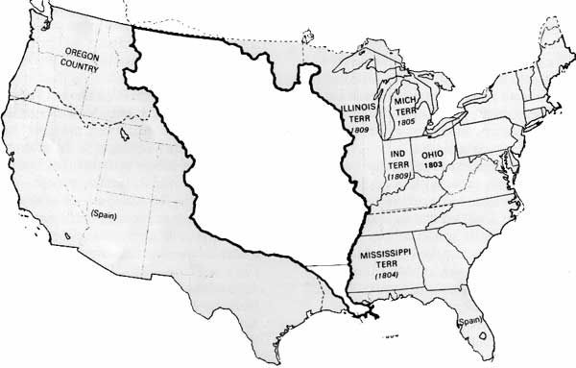
_____ 9. The map on the right shows a piece of land
?????
that was acquired by the United States in
1803. Who was president at this time?
A. George Washington
B. Thomas Jefferson
C. James Madison
D. James Monroe

_____ 10. Which of the first five presidents was not born in Virginia?
A. George Washington C. Thomas Jefferson
B. John Adams D. James Monroe

_____ 11. Which of the following was a weakness of the Articles of Confederation?
A. No executive or judicial branches
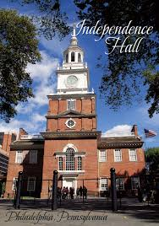
B. Central government printed all the money
C. Strong national government
D. Representation was based on each state’s population

_____ 12. In 1787, why did delegates meet at the building pictured on
the right?
A. To issue a Declaration of Independence against Great Britain
B. To develop create the Articles of Confederation
C. To write a new Constitution
D. To reword the Three-Fifths Compromise

Part V: Short Answer: Please answer each of the below questions in complete sentences.
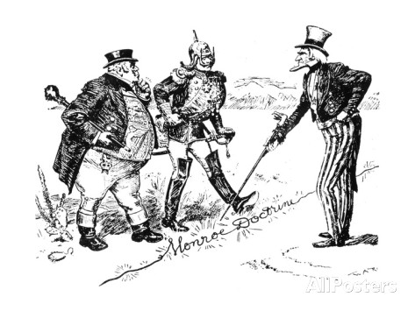
1. How does the picture on the left demonstrate the
Monroe Doctrine?

2. Which war caused European nations to develop respect for the United States?

